**Software Development Fundamentals**

**( Lab – B)**

*Mini Project*

**TITLE: Student Voting System**

Code:

#include<stdio.h>

#include<stdlib.h>

#include<conio.h>

#include<string.h>

#define CANDIDATE_COUNT

#define CANDIDATE1 "Amit"

#define CANDIDATE2 "Rahul"

#define CANDIDATE3 "Akhilesh"

#define CANDIDATE4 "Arvind"

//declaring variables

int votesCount1=0, votesCount2=0, votesCount3=0, votesCount4=0;

static int flag[9];

int main()

{

login();

}

void login()

{

char choice;

system("cls");

printf("\n\n\t\t\t\t ###### Welcome to Election/Voting 2020 #####\n\n");

printf("1. Login as Voter\n");

printf("2. Login as Administrator\n");

printf("3. Exit");

printf("\n\nPlease enter your choice : ");

choice=getch();

fflush(stdin);

switch(choice)

{

case '1': printf("%c\nPlease wait.....",choice);

sleep(1);

loginVoter();

break;

case '2': printf("%c\nPlease wait.....",choice);

sleep(1);

loginAdmin();

break;

case '3': printf("%c\nExiting the program.....\n",choice);

exit(0);

break;

default: printf("Error: Invalid Choice");

sleep(2);

login();

}

}

void loginVoter()//declared function for Voter Login

{

system("cls");

printf("\n\t\t\t\t### VOTER LOGIN ###\n\n");

char stuid[10][10]={"s1","s2","s3","s4","s5","s6","s7","s8","s9"};//Initiallising student id

char id[256],str[256];

int i,j,k,t,cmp,f=0,l;

printf("Enter student Id: ");

fflush(stdin);

gets(id);

fflush(stdin);

for(i=0;i<10;i++)

{

t=0;

for(j=0;j<10;j++)

{

str[j]=stuid[i][j];

}

cmp=strcmp(id,str);

if(cmp==0)

{

//Checking if multiple voting done by one voter

t=id[1]-'0';

if(flag[t-1]==0)

{

flag[t-1]++;

printf("Logging in.....");

sleep(2);

castVote();

break;}

else

{

printf("!! You have already voted for this election !!\nReturning to Home Page...");

sleep(2);

login();

}

}

else if(i==8)

{

printf("!!Incorrect Student Id!!\nReturning to Home Page... ");

sleep(2);

login();

break;

}

}

}

void loginAdmin() //Declared function for Admin Login

{

system("cls");

printf("\n\t\t\t\t### ADMIN LOGIN ###\n\n");

int i,f1=0,f2=0;

char adminid[]="abc";

char adminpass[]="123";

char id[3],pass[3];

printf("Enter Admin ID:");

fflush(stdin);

for(i=0;i<3;i++)

{

scanf("%c",&id[i]);

};

printf("Enter Admin Password:");

fflush(stdin);

for(i=0;i<3;i++)

{

scanf("%c",&pass[i]);

}

for(i=0;i<3;i++)

{

if(adminid[i]==id[i])

f1++;

}

for(i=0;i<3;i++)

{

if(adminpass[i]==pass[i])

f2++;

}

if(f1==3 && f2==3)

{

printf("Logging in.........");

sleep(2);

adminpage();

}

else

{

printf("!! Incorrect Admin Id or Password !!\nReturning to Home Page.....");

sleep(2);

login();

}

}

void castVote(){

//Declared function to caste vote

system("cls");

char choice;

printf("\t\t\t\t### VOTING PAGE ###");

printf("\n\n ### Please choose your Candidate ####\n\n");

printf("\n 1. %s", CANDIDATE1);

printf("\n 2. %s", CANDIDATE2);

printf("\n 3. %s", CANDIDATE3);

printf("\n 4. %s", CANDIDATE4);

printf("\n\n Input your choice (1 - 4) : ");

fflush(stdin);

choice=getch();

fflush(stdin);

printf("%c",choice);

switch(choice)

{

case '1': votesCount1++; break;

case '2': votesCount2++; break;

case '3': votesCount3++; break;

case '4': votesCount4++; break;

default: printf("\nError: Wrong Choice !! Please retry");

sleep(2);

castVote();

}

printf("\n Thanks for voting....... !!");

sleep(3);

login();

}

void adminpage()

//declared function for admin page

{

system("cls");

printf("\t\t\t\t### ADMIN PAGE ###");

char choice;

printf("\n 1. Find Vote Count");

printf("\n 2. Find leading Candidate");

printf("\n 3. Show Winner");

printf("\n 4. Logout");

printf("\n\nPlease enter your choice : ");

fflush(stdin);

choice=getch();

fflush(stdin);

switch(choice)

{

case '1': printf("%c\nPlease wait.....",choice);

sleep(3);

votesCount();

break;

case '2': printf("%c\nPlease wait.....",choice);

sleep(3);

getLeadingCandidate();

break;

case '3': printf("%c\nPlease wait.....",choice);

sleep(3);

getWinner();

break;

case '4': printf("%c\nPlease wait.....",choice);

sleep(3);

login();

break;

default: printf("%c",choice);

printf("\nError: Invalid Choice");

sleep(2);

adminpage();

}

}

void votesCount(){

//declared function to count the votes

system("cls");

printf("\n\n\t\t\t\t ##### Voting Statistics ####\n\n");

printf("\n %s - %d ", CANDIDATE1, votesCount1);

printf("\n %s - %d ", CANDIDATE2, votesCount2);

printf("\n %s - %d ", CANDIDATE3, votesCount3);

printf("\n %s - %d ", CANDIDATE4, votesCount4);

printf("\n\n TOTAL VOTES COUNTED : %d",votesCount1+votesCount2+votesCount3+votesCount4);

sleep(7);

adminpage();

}

int getLeadingCandidate()

{

//declared function to get leading candidate

system("cls");

printf("\n\n\t\t\t\t #### Leading Candidate ####\n\n");

if(votesCount1>votesCount2 && votesCount1>votesCount3 && votesCount1 >votesCount4)

printf("[%s]",CANDIDATE1);

else if (votesCount2>votesCount3 && votesCount2>votesCount4 && votesCount2

>votesCount1)

printf("[%s]",CANDIDATE2);

else if(votesCount3>votesCount4 && votesCount3>votesCount2 && votesCount3

>votesCount1)

printf("[%s]",CANDIDATE3);

else if(votesCount4>votesCount1 && votesCount4>votesCount2 && votesCount4

>votesCount3)

printf("[%s]",CANDIDATE4);

else

printf("----- Warning !!! No-win situation----");

sleep(4);

adminpage();

}

int getWinner(int f[]) //declared function to get Winner

{

system("cls");

printf("\n\n\t\t\t\t #### WINNER ####\n\n");

int count=0,i;

for(i=0;i<9;i++)

{

if(flag[i]>0)

count++;

}

if(count==9)

{

if(votesCount1>votesCount2 && votesCount1>votesCount3 && votesCount1 >votesCount4)

printf(">>[%s]",CANDIDATE1);

else if (votesCount2>votesCount3 && votesCount2>votesCount4 && votesCount2

>votesCount1)

printf(">>[%s]",CANDIDATE2);

else if(votesCount3>votesCount4 && votesCount3>votesCount2 && votesCount3

>votesCount1)

printf(">>[%s]",CANDIDATE3);

else if(votesCount4>votesCount1 && votesCount4>votesCount2 && votesCount4

>votesCount3)

printf(">>[%s]",CANDIDATE4);

else

printf(" ----DRAW---- !!");

sleep(4);

adminpage();

}

else

{

printf(">>>Voting not completed ! Wait till all students have cast their Vote.");

sleep(4);

adminpage();

}

}

1st Output Screen:

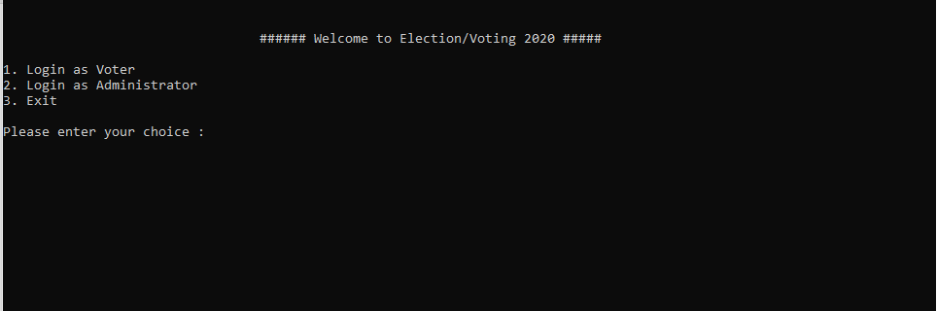

Voter login screen:

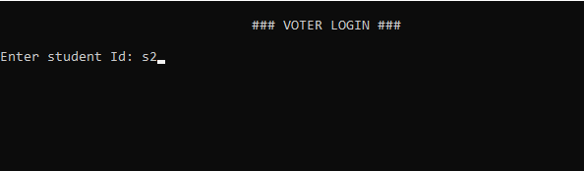

Voting Page:

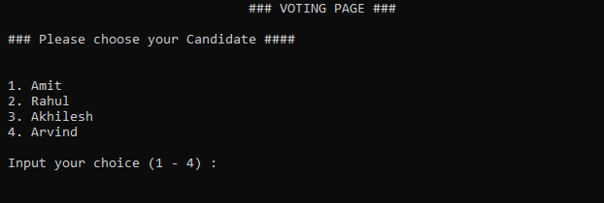

Voted Rahul:

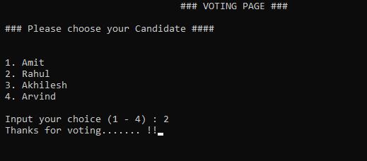

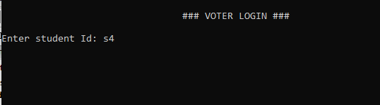

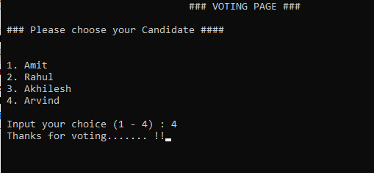

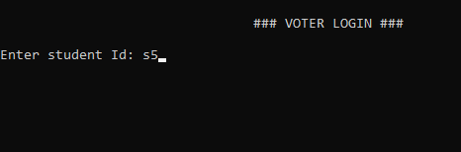

Admin login screen:

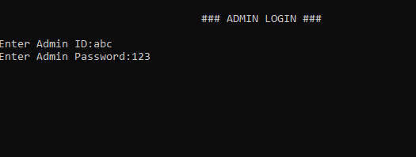

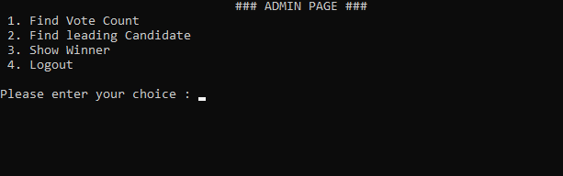

Total Vote Count Screen:

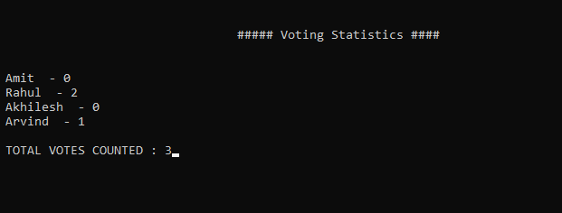

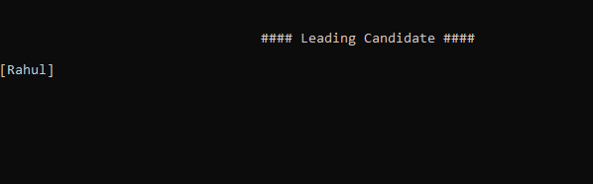

Winner screen:

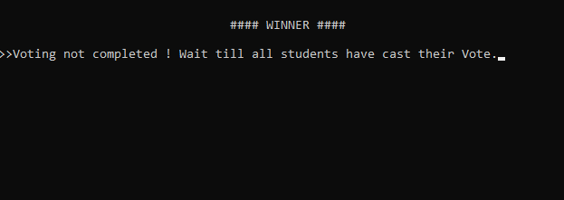

Entered wrong Student Id

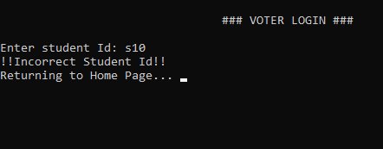

Entered same Id twice:

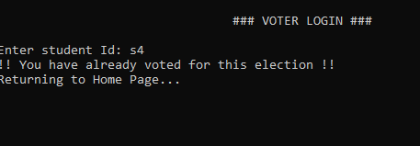

After Completion Of Voting- Vote count screen:

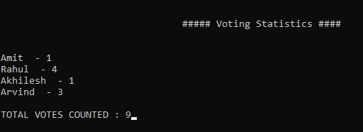

After Completion Of Voting- Winner screen:

